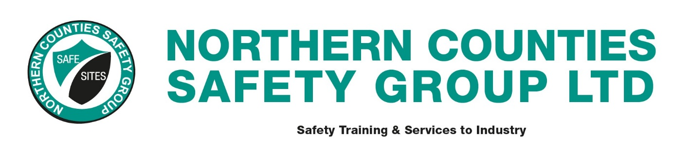

FACT SHEET

Risk Assessment & Safety Method Statements

Introduction
This 1/2-day course of training is intended as an understanding of the requirements of the Management of Health and Safety at Work Regulations, and the requirement placed upon employers under The Health and Safety at Work Act 1974 to develop safe systems of work.

Course Aims
To enable delegates to understand the requirements of modern health and safety regulations and how safe systems of work are developed after carrying out risk assessments.

Who Should Attend
Managers, supervisors and other company personnel, who are involved in determining, setting up, maintaining and supervising safe systems of work

Objectives
- To assist delegates in understanding the requirements of the H.A.S.A.W., M.H.S.A.W.R. and C.D.M Regulations. Also, to show them that all modern health and safety regulations follow a risk assessment based approach.
- To give delegates practice at carrying out risk assessments using different proformas.
- To give delegates the opportunity to develop a risk assessment into a safety method statement.
- To highlight to delegates that risk assessments/safety method statements and possibly permits to work are required under Construction (Design and Management) Regulations.

Instructor
Suitably qualified and practical safety training professionals with many years’ experience in the construction industry.

Trainee Numbers
A maximum of 18 trainees permitted per one instructor.

Achievement Measurement
The delegates and their risk assessments will be assessed throughout the course to ensure they have an understanding of the criteria to be followed when undertaking or developing assessments.

