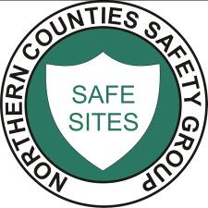NORTHERN COUNTIES SAFETY GROUP LIMITED
Safety Training & Services to the Construction Industry

Safe Use of Circular Saw

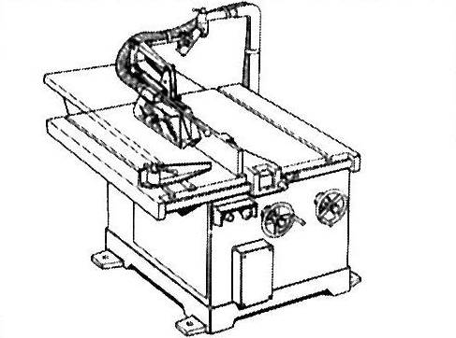

Only trained and authorized employees
to use this machine as per ACOP L114

Safe Use Procedures

- Cutting material to width using rip fence
- Cutting timber to length using the cross cut fence
- Cutting angles using approved guards
- A push stick MUST be available and used at all times
- Blade is to be sharp, of correct size, secure and correctly adjusted
- The gap between saw guard and top of component to be no more than 12mm
- The gap between the front edge of the riving knife and blade must be set as close as possible and within 8mm
- This machine must not be left running unattended
- Use braking devices at all times when stopping the machine
- Ensure the working area around the machine is kept clear at all times
- Correct use of Personal Protective Equipment at all times
- Use of correct Manual Handling techniques at all times

Machine Maintenance and Cleaning

- Employees must not clean the machine whilst still in motion
- Ensure that all maintenance is carried out following the machine manufacturer’s instructions

Limitations

- Rebating and grooving should be carried out on a Vertical Spindle Moulder

