Site: |  |  |  |  |  |  |  | Contract Number:
Assessed by: | Name: |  |  | Position: |  |  |  |  | Date:
 | Signed:
Description Of Work: | Rigging of nets to provide a fall arrest system to those working at height except by rope access.
Task / Job Component | Hazard |  | Persons at risk |  |  | Risk Rating L/M/H | Controls / Precautions to Reduce Risk |  |  |  | Residual Risk Rating  L/M/H
Net rigging. | Falls from height/fragile surfaces. |  | Riggers, other workers, client personnel, general public, visitors. |  |  | H | Use cherry picker or scissor lift for access IPAF qualified. See MEWP risk assessment  - Establish a net tying procedure. Do not secure to scaffold guardrails unless it has been previously requested to permit guardrail design.  - All installers to be FASET registered.  Provide Mobile elevating works platforms and harnesses if fall risk remains  Install temporary covers to fragile surfaces.  Programme the work early to minimise structures being built in the way. |  |  |  | L
 | Manual handling. |  | Riggers, other workers, client personnel, general public, visitors. |  |  | H | Provide clear access routes to work areas.  - Provide sufficient numbers of well supervised operatives to share the manual handling and include training in suitable techniques.  - Drying the nets wherever possible before handling. |  |  |  | L
 | Dermatitis. |  | Riggers, other workers, client personnel, general public, visitors. |  |  | H | Provide suitable gloves and/or barrier cream and reconditioning cream.  - COSHH information if any nets become contaminated. |  |  |  | L
 | Interference with nets. |  | Riggers, other workers, client personnel, general public, visitors. |  |  | H | Inspection of all installed nets every time the area they protect is accessed to monitor interference by third parties.  - Clients control procedures.  - Certification for each net, test tags and individual identification on nets.  - Explanation to client regarding purpose and misuse of nets, and notification to rigger if used to arrest a fall, impacted by material over 40kgs, or damaged (FASET top ten list).  - Removal of nets before hot work. |  |  |  | L
 | Contact with live electrical services. |  | Riggers, other workers, client personnel, general public, visitors. |  |  | M | All power must be isolated and a permit to work issued by an authorised person (Electrical). |  |  |  | L
 | Exposure to asbestos if present. |  | Riggers, other workers, client personnel, general public, visitors. |  |  | M | Suitable asbestos training for all operatives.  - Follow clients procedures using the asbestos survey provided. |  |  |  | L
 | Fall of materials. |  | Riggers, other workers, client personnel, general public, visitors. |  |  | H | Net rigging takes place away from other work.  - Wearing safety helmets. |  |  |  | L
 | Foot injury/blown dust, etc. |  | Riggers, other workers, client personnel, general public, visitors. |  |  | H | Safety footwear and glasses to be worn. |  |  |  | L
Site-specific Activities | Additional Site–specific Hazards |  | Persons at risk |  |  |  | Additional Controls Required

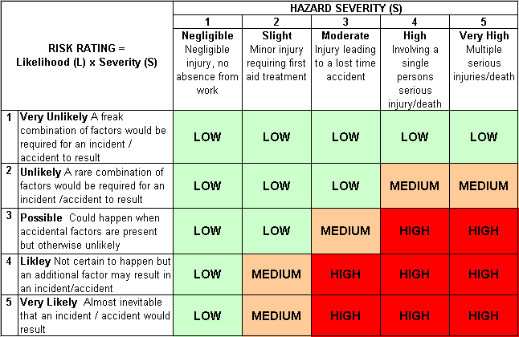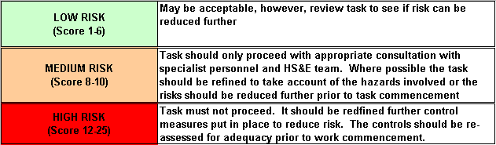Likelihood
How often could the hazard occur? Consider the task, frequency, duration, method of work, employees involved.

Severity

How serious would the hazard’s effects be if
realised? Consider the type of hazard, biological, ergonomic, physical and chemical.

Risk = Likelihood x Severity

E.g. Likelihood (4) X Severity (3) = 12 HIGH RISK

