Site: |  |  |  |  |  |  |  | Contract Number:
Assessed by: | Name: |  |  | Position: |  |  |  |  | Date:
 | Signed:
Description Of Work: | Describe the activity that exposes the operatives to the noise hazard (example operating a stihl saw, operating a nail gun, working in a noisy factory environment etc)
Task / Job Component | Hazard |  | Persons at risk |  |  | Risk Rating L/M/H | Supporting Information used in Assessing the Noise Risk |  |  |  | Residual Risk Rating  L/M/H
Example using a stihl saw to cut flag stones | Noise |  | Operators of the equipment and personnel or public in the immediate vicinity. |  |  | H | What equipment will be used that exposes the operatives to the noise levels?  Stipulate Equipment: example stihl saw, impact drill, breaker
 |  |  |  |  |  | H | What are the noise levels in dB (A)?  The manufactures of the equipment will provide you with information on the noise levels; this will be expressed in dB(A)
 |  |  |  |  |  | H | Have specific measurements been taken on the noise levels?  A competent person can assess specific noise levels. If this has taken place, state results here or attach to this risk assessment. If not undertaken, then use manufacturers noise level.
 | Noise |  | Operators of the equipment and personnel or public in the immediate vicinity. |  |  | H | How many hours will the activity take per day?  Stipulate the length of time the operation will take in hours and minutes. See HSE ready-reckoner below for additional assistance.
 |  |  |  |  |  | H | Are the noise levels significant?  As a simple test, to identify if the noise exposure is medium to high risk. If the following noise levels are exceeded then further controls are required due the noise being significant:  Noise level Duration of Exposure  80dB (A) 6 hours  85dB (A) 2 hours  90dB (A) 45 minutes  For Peak Sound Pressure Level the exposure action value is 135 dB  To comply with the Noise at Work Regulations 2005 the Lower Exposure Action Value is 80dB (A) and the Upper Exposure Action Value is 85 dB(A)  Noise must be reduced to the lowest level practicable. Consider the control measures below.  Also consider using HSE‘s Ready-Reckoner if the employees are exposed to different noise sources throughout the day. www.hse.gov.co.uk and develop an action plan from this information.
Site-specific Activities | Hazards |  | Persons at risk |  |  |  | Control Measures
 | Noise |  | Operators of the equipment and personnel or public in the immediate vicinity. |  |  | H | Eliminate and Control Noise  If possible ELIMINATE and CONTROL exposure to noise at the workplace. Example of elimination would include factory manufacture as opposed to cutting on site, changing the process i.e. bolted as opposed to riveted; change the machine to be fully enclosed during the process, avoid scabbling concrete by changing the design.
 |  |  |  |  |  | H | Design the workplace layout to reduce the noise exposure.  If possible use absorption materials within the building to reduce reflected / reverberated noise.  Segregate noisy equipment or machines from other areas where quiet operations are carried out.  Place screens, enclosures or barriers between the noise source and employees within the workplace.  Select low noise equipment and improved machine design  When purchasing or hiring specify that the equipment has considered noise controls and reduces the noise exposure to the lowest level possible.  Also consider moveable acoustic screens to absorb noise locally and avoiding impacts through buffers to avoid metal on metal contact.  State noise controls here.
Site-specific Activities | Hazards |  | Persons at risk |  |  |  | Control Measures
 | Noise |  | Operators of the equipment and personnel or public in the immediate vicinity. |  |  |  | Reduce the period of noise exposure and establish hearing protection zones.  Job rotation (sharing the noisy work and exposure)  Stagger work activities (breaks) to ensure that workers undertake non noise exposure activities  Designate hearing protection zones in areas were the upper exposure action value of 85dB (A) is exceeded. Ensure signs are displayed and an assessment on the type of hearing protection is made.  Hearing Protection must fit the wearer and protect against the noise levels, but not over protect (avoid hearing protection that would reduce the level at the ear to below 70dB, as this can mask warning signs).  Use HSE hearing protection calculator or discuss with NCSG. www.hse.gov.uk/hearingcalculator Reduce the noise protection quoted by manufacturers by 4dB due to lower level of protection expected in real life situations.
 |  |  |  |  |  | H | Information and training for workers and supervisors  - Workers will be involved when deciding on the control measures.  - Workers will be informed of the noise  - Workers will be informed on the importance of complying with the noise control measures.  - Wear hearing protection when instructed. (Ear muffs, helmet mounted earmuffs, earplugs).
 | Noise |  | Operators of the equipment and employees immediate vicinity. |  |  | H | Health Surveillance  Health surveillance is a programme of health checks to identify early signs and symptoms of hearing loss.  You should provide health surveillance to workers who are regularly exposed to above 85dB (A) or if an individual is sensitive to noise (demonstrated by past medical history or from previous audiometric tests.)  Health surveillance is not appropriate for individuals whose daily exposures exceed 85 dB (A) only on rare occasions and the risk assessment identifies the risk of ill health to be very low.
 | Additional Hazards |  | Persons at risk |  |  |  | Additional Control Measures

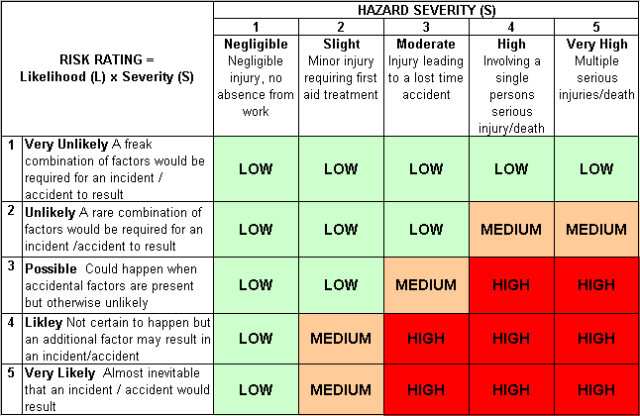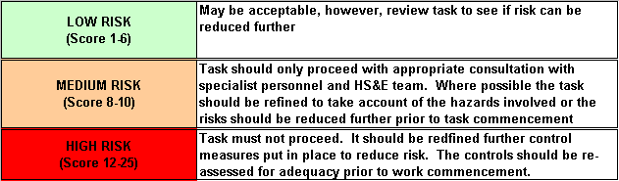Likelihood
How often could the hazard occur? Consider the task, frequency, duration, method of work, employees involved.

Severity

How serious would the hazard’s effects be if
realised? Consider the type of hazard, biological, ergonomic, physical and chemical.

Risk = Likelihood x Severity

E.g. Likelihood (4) X Severity (3) = 12 HIGH RISK

