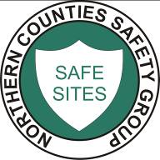NORTHERN COUNTIES SAFETY GROUP LIMITED
Safety Training & Services to the Construction Industry
Safe Use of Narrow Bandsaw

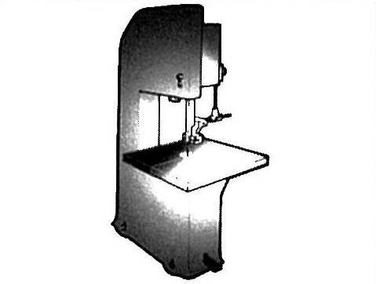

Only trained and authorised employees to use this machine as per ACOP L114

Safe Use Procedures

Use this machine for cutting straight and shaped components

- Ensure the blade is sharp, correctly tensioned and of the correct size for the component
- Where appropriate use a push stick
- Fit and properly adjust all guards and safety devices before starting the machine, in particular the saw guides
- Report any defects immediately to your supervisor
- Do not leave the machine unattended whilst the blade is in motion
- Always use the braking device to stop the machine/blade
- Ensure the working area is well illuminated and is kept clean, clear and tidy
- Use all Personal Protective Equipment (PPE) provided by your employer (e.g. hearing defenders etc)
- Ensure safe Manual Handling techniques are applied at all times

Machine Maintenance and Cleaning

- Do not remove off-cuts, clean the machine or adjust guards whilst the blade is in motion

- Maintain the machine in accordance with the manufacturer’s instructions

