Site: |  |  |  |  |  |  |  | Contract Number:
Assessed by: | Name: |  |  | Position: |  |  |  |  | Date:
 | Signed:
Description Of Work: | Setting up or moving on-site cabins and containers for the storage, offices, workshops, welfare.
Task / Job Component | Hazard |  | Persons at risk |  |  | Risk Rating L/M/H | Controls / Precautions to Reduce Risk |  |  |  | Residual Risk Rating  L/M/H
Temporary accommodation. | Falling materials. |  | Employees, machine operators, delivery drivers, other workers, client’s personnel, general public, visitors. |  |  | H | Competent person to inspect accommodation integrity before lifting.  - Prohibit work below, provide signs and barriers if necessary, secure doors, etc before lifting.  - Use tag lines to control movements. |  |  |  | L
 | Rupture of buried services or collapse of underground voids. |  | Employees, machine operators, delivery drivers, other workers, client’s personnel, general public, visitors. |  |  | H | Detailed site investigation and physical survey of accommodation area and route taken by transport.  - Avoid suspect areas or provide bridging. |  |  |  | L
 | Electrocution through contact when overhead lines. |  | Employees, machine operators, delivery drivers, other workers, client’s personnel, general public, visitors. |  |  | H | Site cabins away from overhead lines ( if this is not feasible consult the owner of the cable to arrange diversion/goalposts, etc. in accordance with GS6).  - Where cabins are to be positioned under overhead lines use wheeled cabins, |  |  |  | L
 | Electrocution through accommodation supplies. |  | Employees, machine operators, delivery drivers, other workers, client’s personnel, general public, visitors. |  |  | H | All wiring and any alterations with certification in accordance with legislation by qualified electricians including portable supplies. |  |  |  | L
 | Fire. |  | Employees, machine operators, delivery drivers, other workers, client’s personnel, general public, visitors. |  |  | H | Ensure all gas equipment and supply pipe work is tested prior to bringing on site, including workers own caravans.  - Provide suitable separation between units and fire points together with emergency plan.  - Consider automatic detection.  - Carry out a fire risk assessment. |  |  |  | L
 | Falls. |  | Employees, machine operators, delivery drivers, other workers, client’s personnel, general public, visitors. |  |  | H | Carry out repairs/painting prior to arrival on site and crane into position using manufacturer’s points of attachment for lifting and suitable lifting equipment.  - Provision of edge protection scaffold to roof edges and tied ladders for roof repairs.  - Assemble any high-level walkways on the ground as much as is practical.  - Connect or disconnect chain hooks from units whilst standing on a footed ladder not from the rooftop.  - Provide means of opening/closing shutters without recourse to a ladder.  - Where possible, use remote release crane hooks. |  |  |  | L
 | Manual Handling. |  | Employees, machine operators, delivery drivers, other workers, client’s personnel, general public, visitors. |  |  | H | Provide training.  - Provide assistance and trolleys or wheelbarrows to handle small components.  - Provide temporary bracing material for timber huts and assembly instructions (suspend work in high winds). |  |  |  | L
 | Nails. |  | Employees, machine operators, delivery drivers, other workers, client’s personnel, general public, young/old/infirm, visitors. |  |  | M | Removal of protruding nails.  - Safety footwear with midsoles. |  |  |  | L
 | Overturning of units or vehicles. |  | Employees, machine operators, delivery drivers, other workers, client’s personnel, general public, young/old/infirm, visitors. |  |  | H | Provide suitable temporary access roads and suitably reinforced bearings for unit leg.  - Ensure route is surveyed and height of plant carrying units is known to ensure clearance under bridges/trees, etc. |  |  |  | L
 | Slips, trips and falls. |  | Employees, machine operators, delivery drivers, other workers, client’s personnel, general public, young/old/infirm, visitors. |  |  | H | Suitable protective footwear for all persons involved and designate safe routes to the area.  Suspend work in inclement weather.  - All surfaces to be walked on, especially steps, to have anti-slip GRP coating. |  |  |  | L

Site-specific Activities | Additional Site–specific Hazards | Persons at risk |  | Additional Controls Required

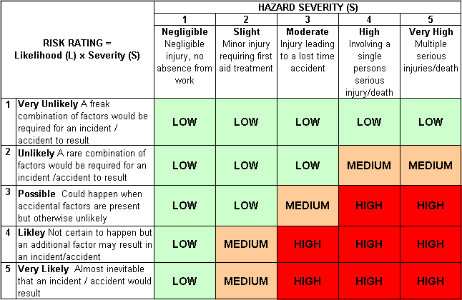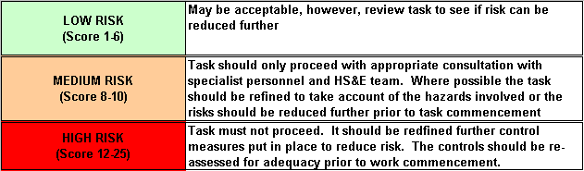Likelihood
How often could the hazard occur? Consider the task, frequency, duration, method of work, employees involved.

Severity

How serious would the hazard’s effects be if
realised? Consider the type of hazard, biological, ergonomic, physical and chemical.

Risk = Likelihood x Severity

E.g. Likelihood (4) X Severity (3) = 12 HIGH RISK

