 |  |  |  |  |  |  |  | Contract Number:
Assessed by: | Name: |  |  | Position: |  |  |  |  | Date:
 | Signed:
Description Of Work: | Use of 6 and 8 wheel tipper wagons
Task / Job Component | Hazard |  | Persons at risk |  |  | Risk Rating L/M/H | Controls / Precautions to Reduce Risk |  |  |  | Residual Risk Rating  L/M/H
Reversing/tipping | Collision with other vehicles and pedestrians |  | Operatives, other contractors, public |  |  | H | - Only drivers with appropriate class of licence to operate lorry (Class 2 HGV)  - Trained banksman to supervise all movements, in particular, reversing.  - All pedestrians and other vehicles to be segregated from area where lorry is operating by physical barriers.  - Reversing cameras to be functional, beacons and audible reversing alarms to be fitted.  - Ensure mirrors are clean and adjusted. |  |  |  | L
Tipping loads | Crushed/trapped by load being tipped |  | Operatives |  |  | M | - Only trained banksman to supervise tipping of loads.  - Banksman to stand well clear of lorry before load is tipped. |  |  |  | L
Tipping loads | Contact with overhead power lines |  | Operatives, drivers |  |  | H | - Tipper bodies must be fully lowered before moving off after tipping.  - Pay attention to signage, goalposts etc. |  |  |  | L
Driving on public roads | Loose debris/Load falling from lorry |  | Other road users, public. |  |  | H | - Sheets to be in place and checked before moving off.  - Driver to check body/tailgate for loose pieces of spoil and clear off. |  |  |  | L
Re-fuelling | Contact with diesel |  | Drivers |  |  | M | - See COSHH assessment for diesel.  - Ensure impermeable gloves are worn whilst refuelling. |  |  |  | L
Maintenance work | Crushing under raised body of tipper |  | Drivers, mechanics |  |  | H | - Only trained mechanics to carry out maintenance work.  - Tipper body to be securely propped to prevent it from dropping, prior to work commencing. |  |  |  | L

Site-specific Activities | Additional Site–specific Hazards | Persons at risk |  | Additional Controls Required

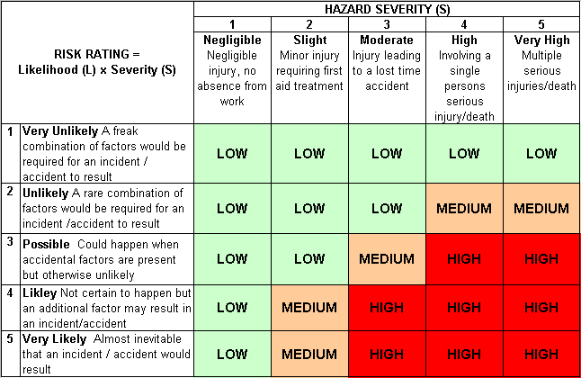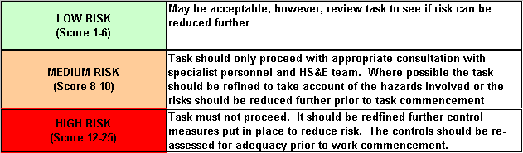Likelihood
How often could the hazard occur? Consider the task, frequency, duration, method of work, employees involved.

Severity

How serious would the hazard’s effects be if
realised? Consider the type of hazard, biological, ergonomic, physical and chemical.

Risk = Likelihood x Severity

E.g. Likelihood (4) X Severity (3) = 12 HIGH RISK

