 | Use of bench grinders/wet grinder |  |  |  |  |  |  | Contract Number:
Assessed by: | Name: |  |  | Position: |  |  |  |  | Date:
 | Signed:
Description Of Work: | Use of bench grinders/wet grinder
Task / Job Component | Hazard |  | Persons at risk |  |  | Risk Rating L/M/H | Controls / Precautions to Reduce Risk |  |  |  | Residual Risk Rating  L/M/H
Use of bench grinders/wet grinder | Abrasions/entanglement |  | Operator |  |  | H | - Only trained persons permitted to use grinders.  - No loose clothing or gloves to be worn. Long hair to be tied back.  - Rest to be adjusted to leave a gap no larger than 10mm between rest and wheel. |  |  |  | L
 | Noise |  | Operator |  |  | M | - Hearing protection to be worn at all times. |  |  |  | L
 | Dust |  | Operator |  |  | M | - FFP3 masks to be worn. |  |  |  | L
 | Ejected particles/burst disc |  | Operator |  |  | M | - Eye protection (face shield or goggles to BS EN166B) to be worn.  - Disc to be inspected before each use for defects/damage.  - Guards to be in place prior to use. |  |  |  | L
 | Electricity |  | Operator |  |  | M | - Check PAT is in date before use. |  |  |  | L
 | Sparks/fire |  | Operator |  |  | M | - Eye protection (face shield or goggles to BS EN166B) to be worn.  - Fire extinguisher to be on hand. |  |  |  | L
 | Vibration |  | Operator |  |  | M | - Only use for short periods (up to 10 minutes). |  |  |  | L

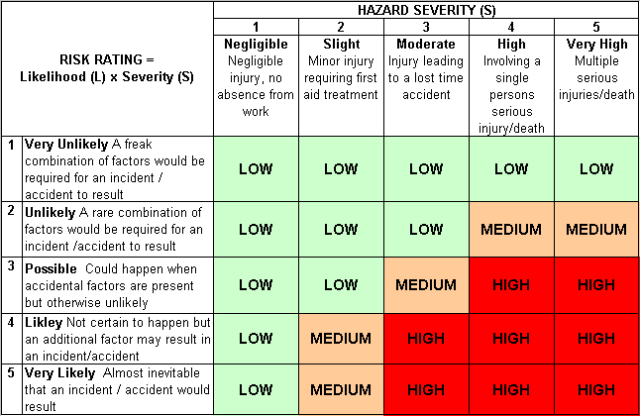
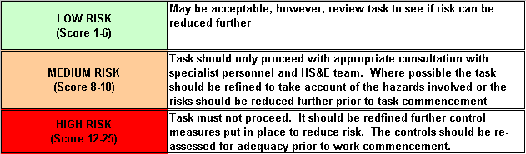
Likelihood
How often could the hazard occur? Consider the task, frequency, duration, method of work, employees involved.

Severity

How serious would the hazard’s effects be if
realised? Consider the type of hazard, biological, ergonomic, physical and chemical.

Risk = Likelihood x Severity

E.g. Likelihood (4) X Severity (3) = 12 HIGH RISK

