 |  |  |  |  |  |  |  | Contract Number:
Assessed by: | Name: |  |  | Position: |  |  |  |  | Date:
 | Signed:
Description Of Work: | Use of Pauloni panel saw for cutting sheet material and timber boards.
Task / Job Component | Hazard |  | Persons at risk |  |  | Risk Rating L/M/H | Controls / Precautions to Reduce Risk |  |  |  | Residual Risk Rating  L/M/H
Use of Pauloni panel saw for cutting sheet material and timber boards. | Cuts, amputation |  | Operator, persons nearby |  |  | H | - Only trained persons permitted to operate machine.  - Check that blades are not worn or damaged (checked daily).  - Ensure other personnel are kept out of exclusion zone painted on floor.  - Push stick to be used for cutting shorter widths of wood.  - Machine to be isolated and locked off after use.  - Machine is maintained annually.  - Safe use instructions are displayed adjacent to machine. |  |  |  | M
 | Noise |  | Operator, persons nearby |  |  | M | - Hearing protection to be worn at all times. |  |  |  | L
 | Dust |  | Operator, persons nearby |  |  | M | - Ensure LEV is switched on before starting work.  - Sundstrom P3 cartridge mask to be worn.  - Operator to be Face Fit Tested for mask. |  |  |  | L
 | Flying particles causing eye injury |  | Operator, persons nearby |  |  | H | - Face shield or Goggles to BSEN 166 B to be worn at all times. |  |  |  | L
 | Slips, trips |  | Operator, persons nearby |  |  | M | - Ensure area around machine is tidy and free from materials and excess sawdust.  - Regularly vacuum up sawdust on floor if required during use.  - Anti-slip paint applied to floor in workshop. |  |  |  | L

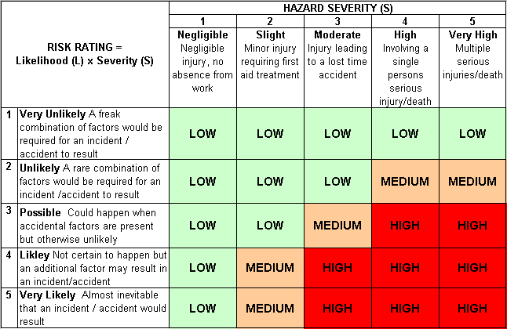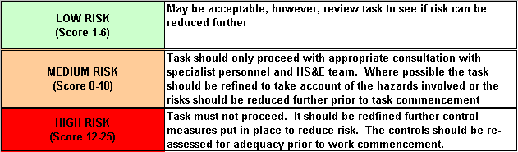Likelihood
How often could the hazard occur? Consider the task, frequency, duration, method of work, employees involved.

Severity

How serious would the hazard’s effects be if
realised? Consider the type of hazard, biological, ergonomic, physical and chemical.

Risk = Likelihood x Severity

E.g. Likelihood (4) X Severity (3) = 12 HIGH RISK

