 | Stanley Knives |  |  |  |  |  |  | Contract Number:
Assessed by: | Name: |  |  | Position: |  |  |  |  | Date:
 | Signed:
Description Of Work: | Use of Stanley Knives to cut DPM/Polythene Sheet
Task / Job Component | Hazard |  | Persons at risk |  |  | Risk Rating L/M/H | Controls / Precautions to Reduce Risk |  |  |  | Residual Risk Rating  L/M/H
Use of knife | Cuts |  | Operative |  |  | H | - Use automatically retractable bladed knives, or safety cutters, NOT fixed blade knives.  - Ensure the blades are sharp.  - Always cut away from the body.  - Wear cut resistant gloves (Kevlar or similar).  - Ensure work area is free from obstructions and clean and tidy. |  |  |  | L
Site-specific Activities | Additional Site–specific Hazards |  | Persons at risk |  |  |  | Additional Controls Required

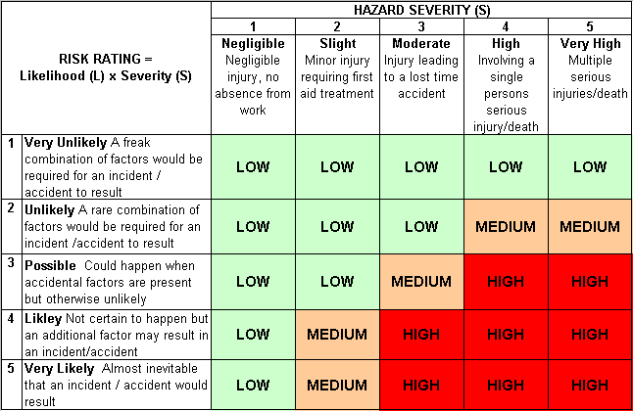
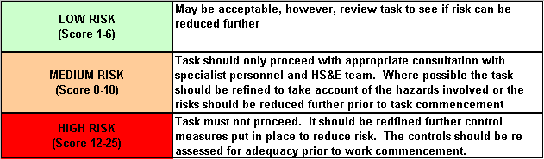
Likelihood
How often could the hazard occur? Consider the task, frequency, duration, method of work, employees involved.

Severity

How serious would the hazard’s effects be if
realised? Consider the type of hazard, biological, ergonomic, physical and chemical.

Risk = Likelihood x Severity

E.g. Likelihood (4) X Severity (3) = 12 HIGH RISK

