Site: |  |  |  |  |  |  |  | Contract Number: |  | n/a
Assessed by: | Name: |  |  | Position: |  |  |  |  | Date:
 | Signed:
Description Of Work: | Installation and use of Oxford Safety Stairwell Platform System
Task / Job Component | Hazard |  | Persons at risk |  |  | Risk Rating L/M/H | Controls / Precautions to Reduce Risk |  |  |  | Residual Risk Rating  L/M/H
Installation | Manual Handling |  | Employees |  |  | M | Weight of system is max 24Kg and designed to be lifted by one person.  - All employees to have manual handling training.  - 2 persons to install system. |  |  |  | L
Installation | Slips, trips and falls |  | Employees, other workers. |  |  | M | - Work area to be free from obstructions and debris prior to installation.  - Ensure that the stairs are clear of materials and trip hazards prior to commencing. |  |  |  | L
Installation | Collapse or failure of system |  | Employees, other workers. |  |  | H | - Ensure system is installed as per manufacturer’s instruction manual.  - The frame must be secured on the top riser with at least 2 x 38 mm screws.  - Before fixing the mat, check all adjusting clamps are tight and frame is secured at top tread. Check that size of mat matches size of frame; mats and frames are colour coded and MUST be used in pairs.  - The locating pins prevent any sliding or movement when the SPS mat is in position. It is therefore important to check that these pins are not damaged or broken. |  |  |  | L
Use | Collapse or failure of system |  | Employees, other workers. |  |  | H | - The mat is not suitable to be loaded out with materials. Maximum spread load is 150 Kg. |  |  |  | L
Site-specific Activities | Additional Site–specific Hazards |  | Persons at risk |  |  |  | Additional Controls Required

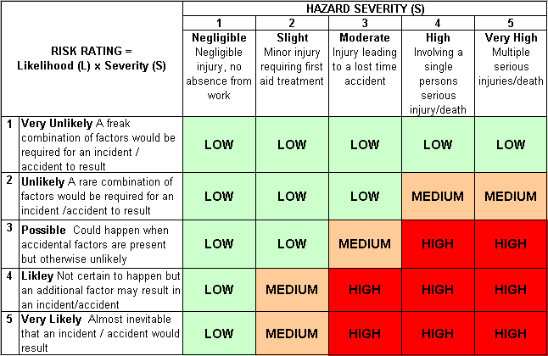
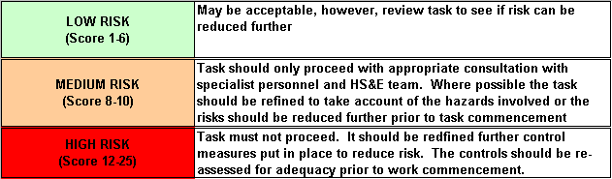
Likelihood
How often could the hazard occur? Consider the task, frequency, duration, method of work, employees involved.

Severity

How serious would the hazard’s effects be if
realised? Consider the type of hazard, biological, ergonomic, physical and chemical.

Risk = Likelihood x Severity

E.g. Likelihood (4) X Severity (3) = 12 HIGH RISK

