COVID 19 VAN CLEANING CHECKLIST
These procedures are to be followed every day your van is in use. It should be cleaned in the morning before use and then after each journey.
Wear disposable gloves and use either sanitising wipes or normal household disinfectant cleaner (Dettox sprays or similar)
- Wash your hands with warm soap and water for at least 20 seconds. If there is no water available use minimum 60% alcohol hand sanitiser.
- Try not to touch your face.
- Make sure you wear disposable gloves. Guidance on how to remove them is on the rear of this checklist.
- Wipe down all external touchpoints: door handles on all doors, including rear doors.
- Inside wipe down:
    - Steering wheel, including horn and infotainment controls
    - Control stalks
    - Ignition and power button
    - Keys
    - Air vents – passenger and central
    - Gear stick
    - Infotainment/radio
    - Heating controls
    - Seatbelts and clips
    - Door handles and releases
    - Door pocket/glove box catch
    - Window switches
    - Interior lights
    - Grab handles
- Once completed. Remove gloves as per instructions overleaf. Dispose of gloves and any used wipes in plastic bags and then place in general waste bins.
- Now wash your hands with warm soap and water for at least 20 seconds. If there is no water available use minimum 60% aclohol hand sanitiser.
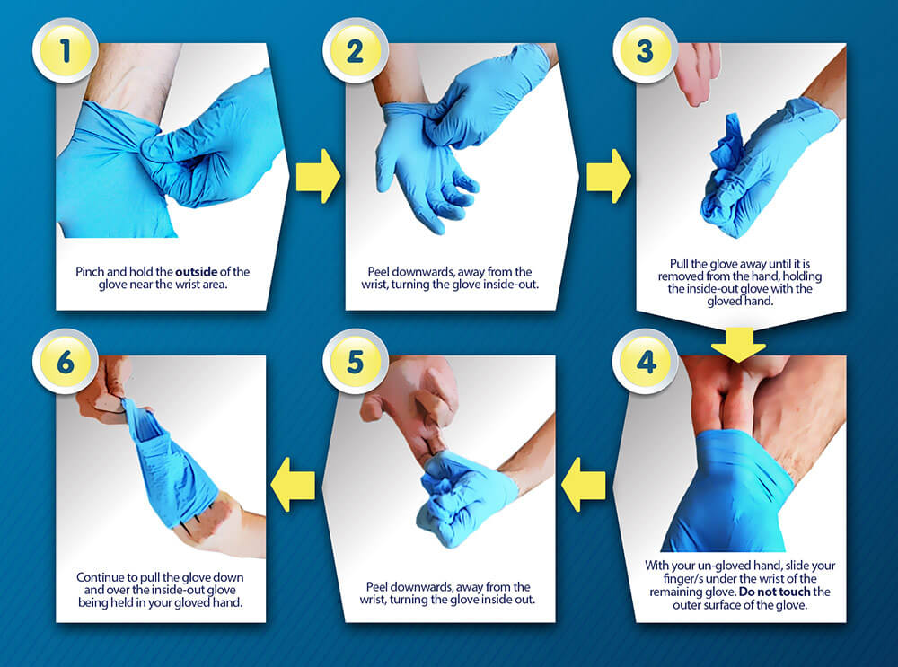
HOW TO REMOVE GLOVES SAFELY

