Northern Counties Safety Group Ltd.

Temporary Works Policy

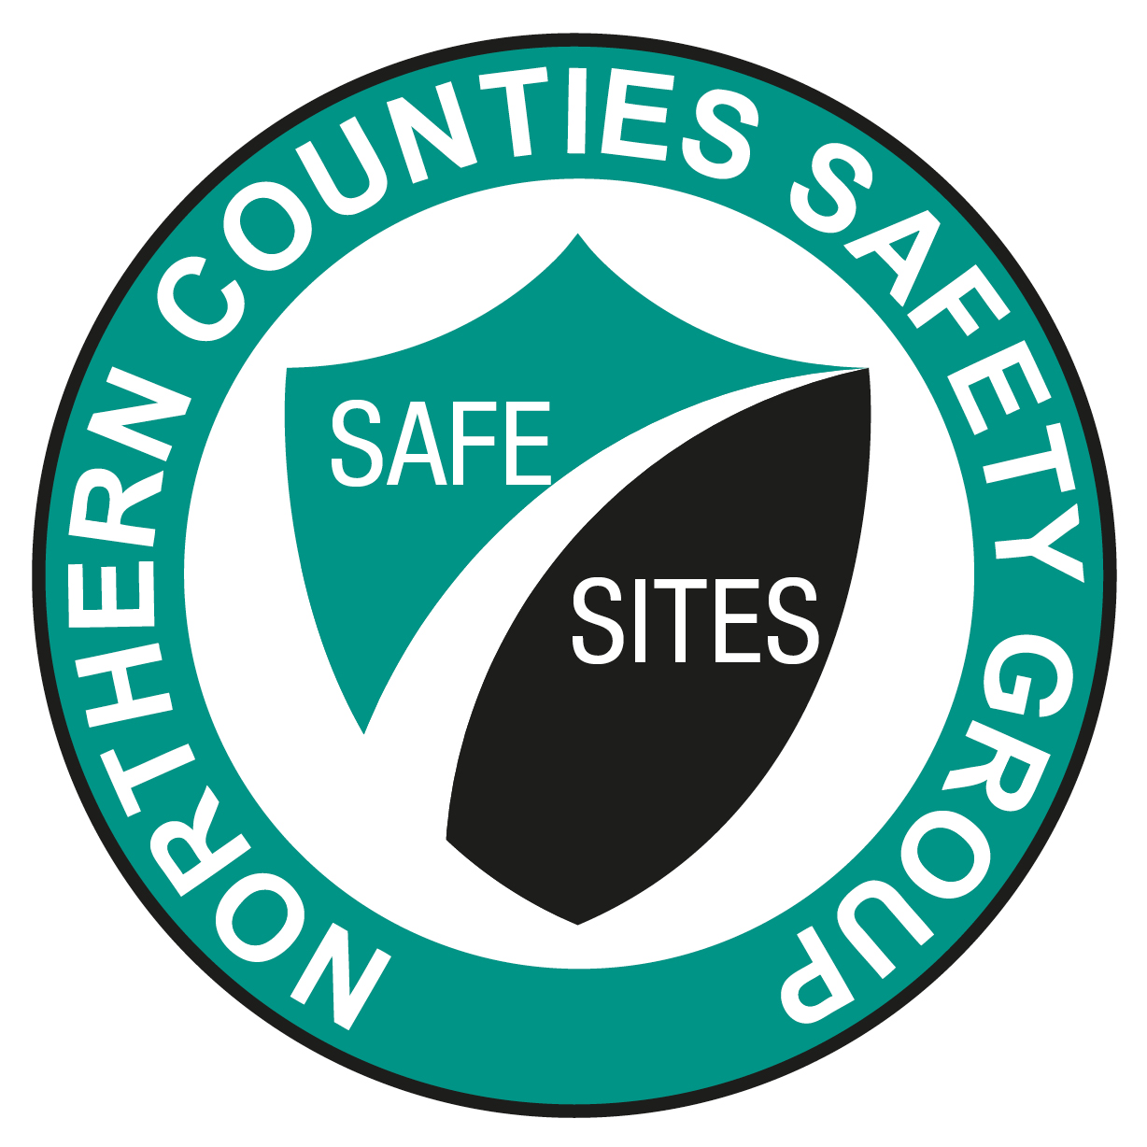

August 2019
Policy Date | Updated by
May 2012 | C. Penketh
May 2013 | C. Penketh
May 2014 | C. Penketh
April 2015 | C. Penketh
April 2016 | N. Redpath
September 2016 | N. Redpath
May 2017 | N. Redpath
August 2019 | N. Redpath

TEMPORARY WORKS POLICY
OBJECTIVE
To ensure appropriate arrangements are in place to manage temporary works that meet the legal requirements of the Construction (Design and Management) Regulations 2015 and effectively manage the risk in compliance with BS 5975 (Code of Practice for Temporary Works) 2019 to ensure all temporary works are conceived, planned, designed, checked, erected, used, inspected and finally dismantled correctly.

INTRODUCTION

The Temporary Works Policy requires that the risks and hazards associated with temporary works are identified, classified and controlled. This procedure is intended to ensure compliance with the companies Temporary Works Policy and covers the following:
- The appointment of personnel responsible for identifying, controlling, designing and constructing temporary works.
- Classification of temporary works according to the risk it brings to the public, the safety of the construction personnel, property and the reputation of the company.
- Management process for temporary works and the procedure for recording each stage in the process.
- The importance of communication between all parties to ensure safe, practicable and economic temporary works solutions.

DEFINITION OF TEMPORARY WORKS

Temporary works are any temporary arrangement required to construct or access the permanent works, or used to support the permanent works during its construction and/or until it becomes self-supporting. This includes scaffolding, edge protection, propping, false-work, safety nets, staircases, formwork etc.
Temporary works can also become part of the permanent structure, if left in situ.

PERSONNEL INVOLVED WITH TEMPORARY WORKS

Designated Individual (DI) companies who are responsible for temporary works need to appoint a designated individual to establish a temporary works procedure and ensure adequate resources are made available.
BS5975 envisages this person to be either the companies engineer or the company’s Operations Director. The DI should be a senior decision maker in the company and must appoint a competent team to implement the temporary works.

Temporary Works Co-ordinator (TWC) – this role will usually be carried out by a Contracts Manager, Project Manager or similar, who has been appointed by the DI. Anyone appointed to be the TWC must have relevant experience and training specific to the role of TWC. They are responsible for ensuring that a temporary works design has been provided and that those installing the temporary works have a suitably developed safe system of work (method statement) and have been briefed in the design and the agreed safe system of work.

PERSONNEL (continued)

Temporary Works Supervisor (TWS) – this role will usually be carried out by the site manager or supervisor (contractors supervisor) and will ensure the temporary works are being erected and used correctly when the temporary works co-ordinator is not on site. Again experience and training in supervising the type of temporary works activities incl. drainage, false-work, propping, scaffold is required. The TWS supervises the installation and removal of the temporary works, requesting inspection and sign offs at the appropriate stage.

Temporary Works Designer (TWD) will most likely be from a specialist contractor or a design organisation. The TWD is responsible for designing the temporary works system using the design brief as a means of interpreting the client’s needs.
The Designer must also ensure that the drawing / design details can be interpreted by the site operatives including dimensions and components to be used.

Temporary Works Design Checker(s) (TWDC) – this role will usually be carried out by the design team to ensure that all designs are suitable. However, if the designs are classed as category 2 or 3 then they should be undertaken by an individual engineer not involved in the design or another external organisation. (see Second Checking the Design).
The categories of temporary works below should be used to establish the level of second check required.
CLASSIFICATIONS OF DIFFERENT TYPES OF TEMPORARY WORKS (TRAFFIC LIGHT SYSTEM)

To assist with the identification of different types of temporary works and level of second check, the following temporary works classifications have been colour coded by NCSG using the traffic light system green, amber and red, with green being lower risk and red being high risk temporary works. The categories should be used to establish the level of second check requested by the Temporary Works Co-ordinator.
Note: The categories 0 to 3 (below) are stipulated in BS 5975 (The Temporary Works British Standard) as a means of specifying the level of checks required for temporary works.
CATEGORY 0
This category will utilise proprietary products, constructed by competent tradesman and be of simple construction to a “standard solution” or manufacturer’s assembly guide. Category O should be second checked by another member of the site team.
CATEGORY 1
Are classified as amber. Category 1 temporary works need to be designed by a competent person and drawings produced for the installers and erectors. These designs should be checked by a member of the design team, with the second checker being qualified to approve the design. (See Qualifications)

CATEGORY 2
Are classified as red and should be designed by a competent person.

To ensure that the design has been carried out correctly, the check should be carried out by an individual not involved with the design, and not consulted by the original designer. However, the second checker can be from the same organisation.
The checker would carry the second check using only the design brief, drawings, photographs of site, equipment specifications etc. The original designers’ calculations should not be passed onto the second checker, thereby ensuring the checker re-calculates the design.
Are also classified as red and should be designed by a competent person.
CATEGORY 3
To ensure that the design has been carried out correctly, an independent engineer from another organisation must be appointed to check the design and produce their own set of calculations before they sign acceptance of the design and drawings.

See below for a more comprehensive list of the categories and the different types of temporary works under each category.
Please note; this is NCSG’s interpretation of the different types of temporary works. The level of second check required is the responsibility of the temporary works co-ordinator (TWC).
CATEGORY 0

In general these are items which can be designed and constructed based on the experience of competent tradesmen following standard solutions, assembly guides, equipment specifications and detailed method statements.

Normally this class of temporary works will utilise proprietary products, assembly guides, British Standards, European guidance and be of simple construction to a “standard solution”.

Examples of temporary works that will normally be Category 0 include:

- Shallow trenches less than 1.2 metres in depth in good ground.
- Proprietary shoring systems (trench and drag boxes) less than 2-metres deep, in good ground.
- Tube and Fitting Scaffolds which are “Basic” as defined inTG20:13 (if in doubt that the scaffold is “Basic” then request a TG20:13 compliance sheet from the scaffold company).
- Un-sheeted, tied scaffolds less than 16m high as per TG20:13 compliance sheets
- Debris netted or sheeted, tied scaffolds less 16m high as per TG20 compliance sheets.
- Internal Birdcage scaffolds as per TG20:13 compliance sheets.
- Roof saddle scaffold as per TG20:13 compliance sheets.
- Loading Bay of 10kN/m² if using a TG20:13 compliance sheet.
- Formwork less than 600mm in height from the ground.
- Edge protection, if a standard solution is available to BSEN13374
- Fences or hoardings up to 1.2 metres high.
- 2 metre high Heras fence panels supported, as per Heras erection guide.
- System scaffolds within the parameters of the assembly guides.
- Haki staircases or similar within the parameters of the assembly guide.
- Free standing aluminium access towers erected and used in accordance with the manufacturers recommendations and PASMA guidance.
- Safety nets secured to robust primary members (i.e. hot rolled steel) as per HSG 33 (HSE guidance for Safety in Roofwork)
- Simple scaffold beam spans less than 6m as per TG20:13 compliance sheets.
- Internal hoarding systems and temporary partitions not subject to wind or differential air pressure or crowd loading.
- Rubbish chutes and gin wheels within the parameters of the manufacturers guide.

The site management team are responsible for checking that the temporary works method statement and risk assessment are specific to the job. Any assembly guides or manufacturers specification documents quoted must be on site and used in the pre-start safety briefing.

The assembly guides must also be used by the inspector to ensure compliance.

CATEGORY 1

Category 1 temporary works which will require design calculations and drawings.

The items listed below can present serious risks when designed or installed incorrectly. Category 1 temporary works need to be designed by a competent person and this design and drawing must be checked by the design team.

Examples of temporary works that will normally be Category 1 include:
- False-work, Propping to support openings and floors, including needling (Strongboys etc).
- Trench excavations up to 3 metres deep. Also see Category 1 for shoring systems.
- Un-sheeted scaffolds whose top lift is higher than 16m. (if a site specific TG20 Compliance sheet is produced , then the scaffold is category O )
- Sheeted scaffolds higher than 16m. (if a site specific TG20 Compliance sheet is produced , then the scaffold is category O )
- System scaffolds outside the assembly guide documents.
- Free standing buttressed scaffold.
  - Edge Protection which does not have a standard solution to BS EN 13374
- Safety net systems which are not fixed to robust primary members (e.g. cold formed sections, secured with anchors) or are of an unusual design.
- Simple bridges with beams and basic scaffold cantilevers, which are not covered by a TG20:13 compliance sheet.
- Loading Bays and working platforms which require greater loading than 3kN/m².
- Fences or hoardings above 1.2 metres high, but are below 3 metres.
- Formwork above 600mm in height from the ground.

CATEGORY 2

Category 2 temporary works which are high risk and must be designed by a competent person. To ensure that the design has been carried out correctly, a second checker not involved with the original design must be consulted as the TW Design Checker for these works.

The following is a typical list of Category 2 temporary works:

- Reinforced concrete foundation for a temporary crane.
- All site signboards, hoardings and fencing over 3m in height.
- Open cut excavations greater than 6 metres deep (geotechnical advice should be sought over 3 metre depth)
- Ground support schemes greater than 3 metres deep, including sheet piling and proprietary support systems.
- Permanent ground support systems (secant/diaphragm walls).
- Cofferdams and Caissons.
- All tower crane bases.
- Facade retention schemes
- Temporary Roofs.
- Rack and Pinion Hoists, mast climbers, etc.
- Jacking schemes.
- Bridge erection schemes (stability checks)
- Complex structural steelwork and pre-cast concrete erection schemes.

continued
CATEGORY 2

- Formwork for concrete walls, columns, etc. higher than 3 metres
- Falsework higher than 3 metres
- All permanent formwork (metal decking etc.)

CATEGORY 3

For complex or innovative designs which result in complex sequences of construction, would be classed as very high risk. Category 3 design must be designed by a competent person and a second check undertaken by an independent organisation.

- Category 3 temporary works are similar to the list in Category 1 and 2, with the only exception being that the designs are unusual and do not follow conventional methods or are in a high risk environment. Example, adjacent to a railway track or Metro rail, Highway Agency work or similar.

Checking and the Temporary Works Register.

All temporary work schemes must be documented in the temporary works register.
Category 1, 2 & 3 designs must undergo a formal check (as stated above) to ensure that the brief has been met; the design complies with current codes, standards and legislation. In addition, the check should address issues of build-ability including maintenance and dismantling, efficiency, robustness and interaction with other concurrent activities. All Category 2 and 3 temporary works must be checked by a person not involved in the original design (category 2) or independent engineer (category 3) and signed off with a secondary check certificate.

CONTROL MEASURES

The control measures required for the safe operation of all temporary works are listed here:-

- The allocation of duties and responsibilities to competent staff for all temporary works activities by the Designated Individual.
- The formal appointment of persons to carry out individual duties.
- The maintenance of a temporary works register.
- The correct classification and assessment of all temporary works.
- The preparation of the concept and design brief based on hazard identification and risk assessment.
- The formal allocation of individual responsibilities to:
Temporary Works Co-ordinator (TWC)
Temporary Works Designer(s) (TWD)
Temporary Works Design Checker(s) (TWDC)
Temporary Works Supervisor(s) (TWS)
- The checking of all materials for adequacy, prior to erection.
- The formal checking of the temporary works design.
- The thorough inspection of the temporary works arrangement before any works or loadings commence.
- The provision of safe access, egress and protective measures to all:
elevated areas.
work areas below ground level.
routes over and across works.
- Regular inspection and maintenance of temporary works
- Formal confirmation that the temporary works is no longer required so that it can be dismantled following a safe system of work (dismantle method statement).

CHECKING AND INSPECTION OF TEMPORARY WORKS
Checking and inspection are essential at every stage of temporary works, from initial concept, through design stage, to erection, use and dismantling.

The Temporary Works Co-ordinator is responsible for setting up the inspection and checking scheme.

RESPONSIBILITY

Responsibility must be allocated by the company for the following key elements of the temporary works usually the responsibility of the Temporary Works Co-ordinator:

- The concept of the scheme.
- The design brief.
- The design - drawings and specification etc.
- Checking of the design.
- Adequacy of materials used.
- Communicating the temporary works details to those who need to know. (e.g. method statements, risk assessments, safety briefings, tool box talk etc.)
- Site control of erection, maintenance and dismantling. (Consider SG4 to prevent falls during the erection and dismantling of scaffolding temporary works).
- Inspection and records of the temporary works. (E.g. prior to first use inspection, handover certs, permits to load and every 7 days)
- Authority to use the temporary works and completion / dismantle.
