Company Name:  Site: |  |  | COSHH  Assessment
Supplier: | CHAUCER SOLUTIONS LTD |  | COSHH Number | 08
 |  |  |  | page 1
Assessment By: | Activity: |  | Review Date | Assessment Date
 | Cleaning and lubrication of scaffolding clips
 | Persons/Groups at Risk
 | Scaffolders

NAME OF HAZARDOUS SUBSTANCE USED OR CREATED
Substance: Clip Free

 | 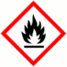 |  |  | 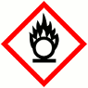 |  |  | 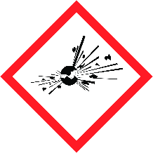 |  |  |  |  |  |  |  |  | 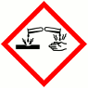
 | FLAMMABLE |  |  | OXIDISING |  |  | EXPLOSIVE |  |  | IRRITANT |  |  | HARMFUL |  |  | CORROSIVE
 | YES | NO |  | YES | NO |  | YES | NO |  | YES | NO |  | YES | NO |  | YES | NO
 | Insert in appropriate boxes
 | 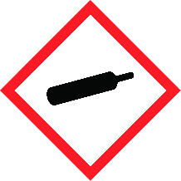 |  |  | 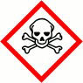 |  |  | 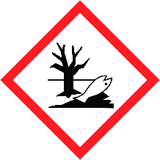
 | COMPRESSED GAS |  |  | TOXIC |  |  | HARMFUL TO THE EINVIRONMENT
 | YES | NO |  | YES | NO |  | YES | NO |  | YES | NO |  | YES | NO |  | YES | NO

Insert in appropriate boxes

Please add comments into boxes where required. |  | Insert in appropriate boxes |  | YES | NO
Is Manufacturers Safety Data Sheet available?
Does the Substance have a Workplace Exposure Limit (WEL)?
If the substance has a WEL please state. if un-sure check HSE document – EH40 |  |  | 5mg/m3
Can a safer substance be used or can the substance be enclosed or extracted.
Will employees be given information and training?
Will Personal Protective Equipment be provided for employees?
State the standard of RPE (respirators) |  |  | Not necessary in well ventilated areas
State the standard of Goggles or Spectacles |  |  | BS EN166 safety glasses
State the standard of Gloves |  |  | Nitrile/PVC gloves to be worn
State the standard of Overalls
State the standard of Boots |  |  | BS EN345
Other Equipment |  |  | Attach details if YES
Will Exposure Monitoring and/or Control Measures be required? |  |  | Attach details if YES
Will Health Surveillance be necessary? |  |  | Attach details if YES
Does this Substance need to be disposed of by a Waste Disposal Contractor?
Have all necessary First-aid requirements been provided?
Have Storage requirements for the substance been provided/arranged on site?
FIRST AID, FIRE FIGHTING, STORAGE & HANDLING, DISPOSAL AND ACCIDENTAL RELEASE INSTRUCTIONS ARE PROVIDED ON PAGES 2 & 3 |  |  | Number of Sheets attached to this Assessment

FIRST AID INSTRUCTIONS
Route of Exposure, or  Type of Injury | First Aid Treatment
Skin Contact | Wash skin with large amounts of water. If irritation persists seek medical advice
Eye Contact | Irrigate with eyewash solution or clean water, holding eyelids apart for 10 minutes.  Get immediate medical attention.
Inhalation | Remove from exposure, rest and keep warm. Seek immediate medical attention.
Ingestion | Wash out mouth with water. Do not induce vomiting. Give water to drink if patient feels  unwell. Get medical attention immediately.
General Information

FIRE FIGHTING MEASURES
Hazard | Measures
Fire | Extinguish with Dry Powder, Foam or Water Fog. Do not use water jets.  Fires in closed or confined spaces should be tackled by trained personnel who should wear breathing apparatus. Possible risk of can rupture when exposed to fire/high temperatures.
Stability | Stable under normal temperature conditions. May react with strong oxidising materials.
Decomposition Products | Fire or high temperatures create halogenated hydrocarbons oxides of carbon.

MANUFACTURERS INFORMATION
Manufacturers Name and Address | CHAUCER SOLUTIONS LTD  LEYCOURT FARM  GT GRANSDEN  BEDS  SG19 3AS
Manufacturers Health & Safety Data Sheet Reference | N/A
24 Hour Emergency Telephone Number | 01767 677445
Regulatory Information: Warning Label Phrases | Not classified as hazardous for supply. No statutory label required.

Regulatory Information: Warning Label Phrases | Not regarded as a health or environmental hazard under current legislation.

STORAGE AND HANDLING
Hazard | Measures
Handling | Avoid spilling, skin and eye contact.
Storage | Store upright in container provided. Avoid extremes of temperature.

DISPOSAL MEASURES
Hazard | Measures
Pollution of water courses or drains | Small spillages: Rinse with water into the drain. Large spillages: Absorb with granules.

ACCIDENTAL RELEASE MEASURES
Hazard | Measures
Spillage | Small spillages: Rinse with water into the drain. Large spillages: Absorb with granules.

USAGE/EXPOSURE
Frequency and Duration of use
Maximum number of people involved in activity
Quantities stored/used
Exposure levels

Safe System of Work

1. Wash at the end of each work shift and before eating, smoking and using the toilet.

2. Ensure spill kit is close at hand.

3. Ensure PVC/Nitrile gloves are worn.

4.

5.

6.
7.

8.

Operatives Acknowledgement

Name: | Signature: | Date: | Name: | Signature: | Date:

