Company Name:  Site: |  | 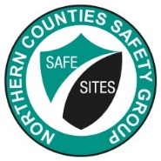 | COSHH  Assessment
Supplier: | Banner Chemicals Group |  | COSHH Number | 30
 |  |  |  | page 1
Assessment By: | Activity: |  | Review Date | Assessment Date
 | Adblue additive for diesel engines
 | Persons/Groups at Risk
 | Fitters, Plant operators

NAME OF HAZARDOUS SUBSTANCE USED OR CREATED
Adblue

 | 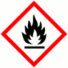 |  |  | 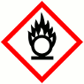 |  |  | 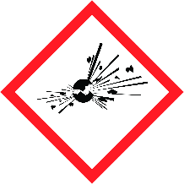 |  |  |  |  |  | 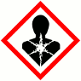 |  |  | 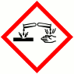
 | FLAMMABLE |  |  | OXIDISING |  |  | EXPLOSIVE |  |  | IRRITANT |  |  | HARMFUL |  |  | CORROSIVE
 | YES | NO |  | YES | NO |  | YES | NO |  | YES | NO |  | YES | NO |  | YES | NO
 | Insert in appropriate boxes
 | 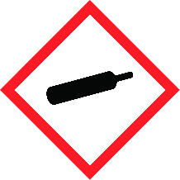 |  |  | 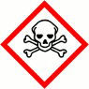 |  |  | 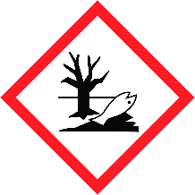
 | COMPRESSED GAS |  |  | TOXIC |  |  | HARMFUL TO THE EINVIRONMENT
 | YES | NO |  | YES | NO |  | YES | NO |  | YES | NO |  | YES | NO |  | YES | NO

Insert in appropriate boxes

Please add comments into boxes where required. |  | Insert in appropriate boxes |  | YES | NO
Is Manufacturers Safety Data Sheet available?
Does the Substance have a Workplace Exposure Limit (WEL)?
If the substance has a WEL please state. if un-sure check HSE document – EH40
Can a safer substance be used or can the substance be enclosed or extracted.
Will employees be given information and training?
Will Personal Protective Equipment be provided for employees?
State the standard of RPE (respirators)
State the standard of Goggles or Spectacles |  |  | BS EN166 safety glasses/goggles
State the standard of Gloves |  |  | PVC without knitted backs or knit wrists
State the standard of Overalls
State the standard of Boots |  |  | ISO EN20345
Other Equipment |  |  | Attach details if YES
Will Exposure Monitoring and/or Control Measures be required? |  |  | Attach details if YES
Will Health Surveillance be necessary? |  |  | Attach details if YES
Does this Substance need to be disposed of by a Waste Disposal Contractor?
Have all necessary First-aid requirements been provided?
Have Storage requirements for the substance been provided/arranged on site?
FIRST AID, FIRE FIGHTING, STORAGE & HANDLING, DISPOSAL AND ACCIDENTAL RELEASE INSTRUCTIONS ARE PROVIDED ON PAGES 2 & 3 |  |  | Number of Sheets attached to this Assessment

FIRST AID INSTRUCTIONS
Route of Exposure, or  Type of Injury | First Aid Treatment
Skin Contact | Wash skin thoroughly with soap and water. Remove contaminated clothing. Get medical  attention if irritation persists after washing.
Eye Contact | Remove any contact lenses and open eyelids wide apart. Continue to rinse for at least 15  minutes. Continue to rinse for at least 15 minutes. Get medical attention if any discomfort  continues
Inhalation | Remove affected person from source of contamination. Get medical attention if any discomfort continues.
Ingestion | Do not induce vomiting. Get medical attention if any discomfort continues.
General Information | No additional symptoms or effects are anticipated

FIRE FIGHTING MEASURES
Hazard | Measures
Fire | Use foam, carbon dioxide, dry powder or water fog to extinguish
Stability | There are no known reactivity hazards associated with this product.
Decomposition Products | Ammonia

MANUFACTURERS INFORMATION
Manufacturers Name and Address | Samuel Banner & Co Ltd  Hampton Court  Manor Park  Runcorn  Cheshire  WA7 1TU, UK
Manufacturers Health & Safety Data Sheet Reference | 4303
24 Hour Emergency Telephone Number | 0207 405 5375 (National Chemical Emergency Centre) 0870 190 6777 (National Chemical  Emergency Centre) +44 (0)1270 502891
Regulatory Information: Warning Label Phrases | P305+P351+P338 IF IN EYES: Rinse cautiously with water for several minutes. Remove contact lenses, if present and easy to do. Continue rinsing.

STORAGE AND HANDLING
Hazard | Measures
Handling | Avoid contact with skin and eyes. Provide adequate ventilation
Storage | Store at moderate temperatures in dry, well ventilated area. Store in closed original container  at temperatures between 0°C and 30°C. Do not use containers made of the following  materials: Copper and its alloys. Galvanised containers.

DISPOSAL MEASURES
Hazard | Measures
Pollution of water courses or drains | Absorb spillage with non-combustible, absorbent material. Collect and place in suitable waste disposal containers and seal securely. Flush contaminated area with plenty of water.  Do not allow to enter water courses or drains.

ACCIDENTAL RELEASE MEASURES
Hazard | Measures
Spillage | Contain spillage with sand, earth or other suitable non-combustible material. Avoid discharge into drains or watercourses or onto the ground.

USAGE/EXPOSURE
Frequency and Duration of use | Weekly up to 2 hours
Maximum number of people involved in activity | 2
Quantities stored/used | 1000 litres IBC
Exposure levels | N/A No WEL, non-hazardous

Safe System of Work

1. All correct PPE to be worn, particularly gloves an eye protection.

2.

3.

4.

5.

6.

7.

8.

9.

10.
Operatives Acknowledgement

Name: | Signature: | Date: | Name: | Signature: | Date:

