Assessed by: | Name: |  |  | Position: |  |  |  | Date:
 | Signed:
Description of Work: | Working in offices
Task / Job Component | Hazard |  | Persons at risk |  |  | Risk Rating L/M/H | Controls / Precautions to Reduce Risk |  |  | Residual Risk Rating  L/M/H
General work activities office | Contact with materials, surfaces or inhaled into the lungs from an affected person. |  | All employees, visitors |  |  | H | Cover your mouth and nose with a tissue or your sleeve (not your hands) when you cough or sneeze.  - Put used tissues in the bin straight away  - Wash your hands with soap and water on arrival to office and often during the day – use hand sanitiser gel if soap and water are not available (20 seconds washing).  - Consider hand sanitiser at office entrances for anyone to use before coming onto office.  - Encourage employees to take lateral flow tests twice weekly.  - Clean and disinfect frequently touched objects and surfaces using normal cleaning products.  - Consider cleaning canteen and toilet areas at least 4 times per day.  - Stagger mealtimes to reduce numbers in canteens.  - Do not touch your eyes, nose or mouth if your hands are not clean.  - Display Health Bulletin/posters from government information within toilet and canteen areas.  - Toolbox talk on good hygiene practices.  - Avoid “hotdesking” or sharing of workstations.  - Regularly clean common touchpoints, doors, buttons, handles, desktops, equipment etc.  - Increase ventilation in offices by opening windows.  - Where air conditioning recirculates air. Turn it off and aim to have a flow of fresh air by opening windows and doors where possible.  - Consider CO₂ monitors in areas with larger numbers of people working. HSE Guidance can be found here.  - Workers should wash their hands before and after using any equipment |  |  | M
Travelling to and from work | Contact with materials, surfaces or inhaled into the lungs from an affected person. |  | Employees |  |  | H | - Good ventilation (i.e. keeping the windows open) and facing away from each other may help to reduce the risk  of transmission.  - Workers to wash their hands for 20 seconds using soap and water or hand sanitiser if soap and water are not available before entering and after getting out of the vehicle.  - Workers should avoid touching their faces.  - The vehicle should be cleaned regularly using gloves and standard cleaning products, with particular emphasis on handles and other areas where passengers may touch surfaces.  - Workers travelling on public transport must wear face coverings.
Anyone showing symptoms/self-isolation | Spread of infection |  | All members of staff, clients, visitors and general public |  |  | H | - Any worker who takes ill or showing signs of COVID19 symptoms (below) should be sent off site immediately and take a PCR test. If positive, they must self-isolate for 10 days.  Workers with a persistent cough or temperature over 37.8°C  - A loss of, or change in, your normal sense of taste or smell (anosmia)  - Anyone who is a contact of someone who may have been infected with the Omicron variant, must self-isolate for 10 days, regardless of their age, vaccination status or any negative test results. NHS Test and Trace will contact them if this is the case.  - Those who live in the same household or have had close contact with someone who has tested positive are advised to take a PCR test. If they are fully vaccinated, they do not have to self-isolate. Details can be found here.  - Anyone who has returned from a country that is on the Red list must self-isolate for 10 days. The list can be found here  Anyone having a positive test result shall Self-isolate at home for 10 days. |  |  | M
Confirmed cases of Covid19 | Spread of infection from person’s work area |  | Employees, visitors |  |  | H | Isolate area/room and restrict access.  Area/room to have deep clean and disinfected by specialist cleaning contractor.  - Any staff reporting symptoms to be tested and self-isolate, if positive. |  |  | M
Meetings | Spread of infection |  | All members of staff, clients, visitors and general public |  |  | H | Face to face meetings shall be avoided where this is practical, try to use emails, phone calls, conference calls video calls etc. to minimise need.  Where meetings are unavoidable minimise the number of personnel present and follow good hygiene protocols.  - Rooms should be well ventilated / windows opened to allow fresh air circulation. |  |  | M
Use of PPE | Spread of infection |  | All members of staff, clients, visitors and general public |  |  | H | - Workers may wish to wear cloth face coverings. Cloth face coverings do not offer protection against COVID-19 to the user and are not a substitute for the other measures outlined in this risk assessment. However, face coverings may be marginally beneficial to others, if the user is asymptomatic. If workers choose to wear a face covering, you may wish to support them in doing so safely, by telling them:  - Employers should support their workers in using face coverings safely if they choose to wear one. This means telling workers to:  - Wash their hands thoroughly with soap and water for 20 seconds or use hand sanitiser before putting a face covering on, and after removing it.  - Avoid touching their face or face covering, as it could contaminate them with germs from their hands.  - Change their face covering if it becomes damp or if they’ve touched it.  - Continue to wash their hands regularly.  - Change and wash their face covering daily.  - If the material is washable, wash in line with manufacturer’s instructions. If it’s not washable, dispose of it carefully in their usual waste.
Administering First Aid | Spread of infection |  | Persons administering first aid |  |  |  | If someone needs emergency first aid at work, go through the normal triage process and call the emergency services if necessary.  In other situations, maintain social distancing where possible and make sure as few people as possible go near the injured person.  If the situation allows, provide advice and instruction to enable the person to carry out first aid on themselves.  If you do need to administer first aid you should take appropriate precautions including:  - Wear disposable gloves, and a disposable plastic apron.  - The use of a fluid repellent surgical face mask is recommended and additional use of disposable eye protection (such as face visor or goggles) should be worn when there is an anticipated risk of contamination with splashes, droplets of blood or body fluids.  - Avoid touching your face or other parts of your body that may lead to you becoming infected.  - Remove the gloves carefully when you have completed your first aid and immediately wash or sanitize your hands  - Try to reduce the amount of time you are in close proximity to the patient.  - Administer the first aid, make them comfortable and then go to a safer distance  - If appropriate you may want to ask them to turn their head away from you while you are administering first aid to reduce the risk of being exposed to respiratory droplets.  If you are required to perform cardiopulmonary resuscitation (CPR)  - In adults, it is recommended that you do not perform rescue breaths or mouth-to-mouth ventilation; perform chest compressions only.  - Compression-only CPR may be as effective as combined ventilation and compression in the first few minutes after non-asphyxial arrest (cardiac arrest not due to lack of oxygen).  After performing compression-only CPR, all rescuers should wash their hands thoroughly with soap and water; alcohol-based hand gel is a convenient alternative.
Office-specific Activities | Additional Office–specific Hazards |  | Persons at risk |  |  |  | Additional Controls Required

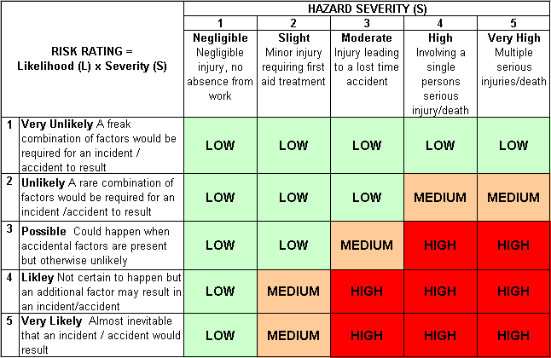
Likelihood
How often could the hazard occur? Consider the task, frequency, duration, method of work, employees involved.

Severity

How serious would the hazard’s effects be if
realised? Consider the type of hazard, biological, ergonomic, physical and chemical.

Risk = Likelihood x Severity

E.g. Likelihood (4) X Severity (3) = 12 HIGH RISK
LOW  1-6 | Minor harm possible, serious harm very unlikely to occur, implement controls and ensure care is taken when performing activity
MEDIUM  8-10 | Moderate degree of harm possible, major harm unlikely to occur, critically assess the risks and appropriate controls. Specific competence required and ongoing assessment of risks by individual and supervisor
HIGH  12-25 | Serious or major harm will probably occur; Stop the activity and critically assess the risks, review safety aspects of activity and implement further appropriate controls.

