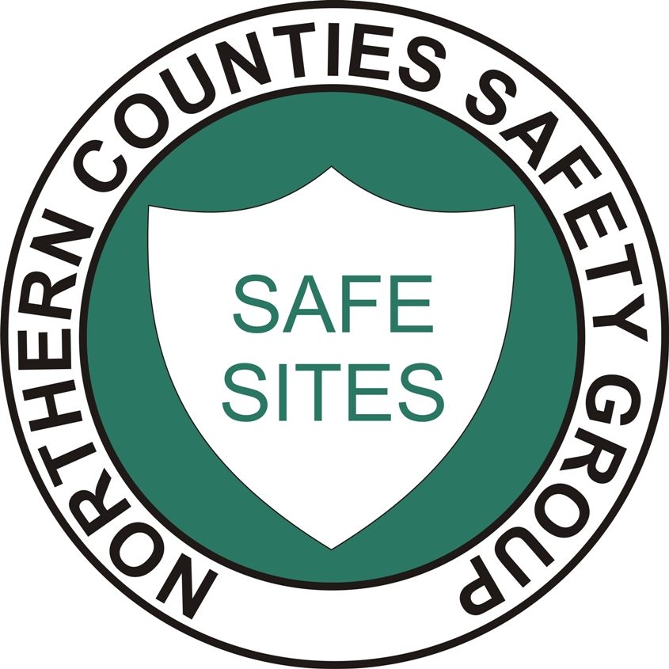

ADVANCED GUARDRAIL SYSTEM

METHOD STATEMENT

CLIENT:

SITE: DATE:

Supervisor and Emergency Contact
Name:
Telephone No:

The Advanced Guard-rail System (AGS) will be used as fall prevention for the scaffolders. The AGS will mitigate the risk of a fall when traversing along a boarded lift.

The AGS system has been tested in compliance with BS EN 12811-1. The telescopic guardrails are load tested to 1.4kN. The quick locating claw has been load tested to 13kN pull-off force.

The risk of falls can not be totally eliminated therefore; the scaffolders will be wearing full body harness in compliance with BS EN 361 and a shock absorbing lanyard in compliance with BS EN 355. The lanyard will be secured if exposed to an open leading edge.

Prior to the commencement of work, all scaffolders will be instructed on the contents of the safety method statement and will sign the acceptance sheet.

The advanced guardrail safe system of work is as follows:
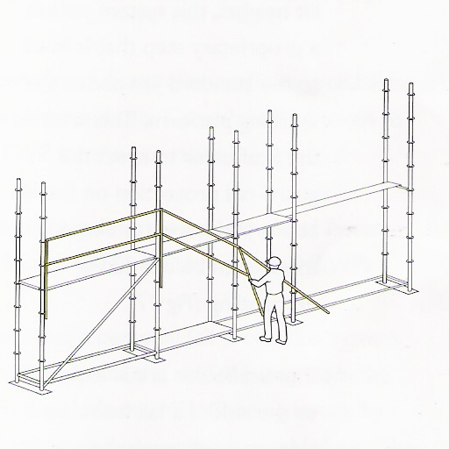
- Upon completion of the first lift, boards will be placed onto the lift. A platform will be created which will be fully decked leaving a gap for access to the ledger. The exposed ledger can be used as an anchorage point if required.

- The scaffolders will now erect the AGS from ground floor level as per diagram. This process eliminates the need to work at height.

- The scaffolders will now secure a ladder to allow safe access onto the first lift and will check that all the connection points and securing claws are secure on the AGS. Any defective items must be reported to the supervisor for immediate removal.

- Upon completion of the check. A single guardrail will be installed at least 950mm above the deck level on each face of the scaffold where a fall could occur. This guardrail should be erected and left in place throughout the life of the scaffolding.

- The scaffolders can now safely construct the second lift. If a fall risk remains due to the complexity of the structure, then the scaffolder will secure his harness to the highest anchorage point.
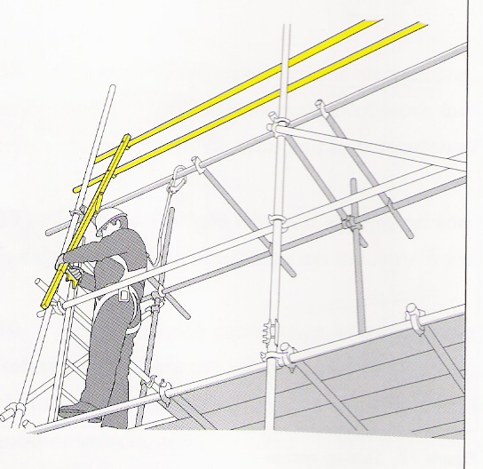
- Upon completion of the second lift. The AGS can now be lifted to provide fall protection to the next lift.

- The AGS is fitted with extendable ledgers which will aid moving without exposing the scaffolder to any manual handling risks.

- The scaffolder will now repeat the inspection of the AGS and when satisfied, will complete the erection of the next lift.

- Note: on non boarded lifts the single guardrail will remain in position. This will act as fall prevention and a harness securing point in the event of a modification to the scaffold being requested.

Date…………………………

THIS SAFE SYETEM OF WORK IS TO BE READ IN CONJUNCTION WITH THE WORKS RISK ASSESSMENT AND SAFETY METHOD STATEMENT.

ANY VARIATIONS TO THE METHOD STATEMENT MUST BE AUTHORISED BY THE CONTRACTS MANAGER OR THE SAFETY MANAGER.
Implementation

This method statement is to be signed by all members of the team attending safety briefing.

WE THE UNDERSIGNED AGREE TO WORK WITHIN THE SAFE SYSTEM OF WORK SET OUT IN THIS METHOD STATEMENT.

Contracts Managers Name:
Date:
Signature:

Operatives Acknowledgement

Name: | Signature: | Date: | Name: | Signature: | Date:

NCSG CP/AGS

